**Table of Content**

ACKNOWLEDGEMENT i

ABSTRACT ii

LIST OF TABLES vi

LIST OF FIGURES vii

LIST OF ABBREVIATIONS viii

CHAPTER 1:INTRODUCTION 1

1.1 Project Summary 1

1.2 Scope and Limitations 1

1.2.1 Scope 1

1.2.2 Limitations 2

1.3 Problem Statement 2

1.4 Objectives 2

1.5 Introduction to Company 2

1.5.1 Company Background 2

1.5.2 Contact Details 3

1.5.3 Organization Hierarchy 4

1.6 Internship Information 5

1.7 Responsibility Assigned 5

CHAPTER 2:LITERATURE REVIEW 6

2.1 Similar Existing Content Management System 6

2.2. Introduction 7

2.3. Importance of website 8

2.4. System Development Methodology 8

2.4.1. Comparative Study of Development Methodology 8

2.4.1.1. Prototyping Model 8

2.5. Tools for Dynamic Website 9

2.5.1. PHP 9

CHAPTER 3:SYSTEM ANALYSIS 10

3.1. Requirement Collection 10

3.1.1. Use Cases 10

3.1.2. Observation 10

3.2. System Requirements 10

3.2.1. Functional Requirements 10

3.2.2. Use case Diagram 12

3.2.3 Non-functional Requirements 17

3.2.3.1 Performance 17

3.2.3.2 Hardware 17

3.2.3.3 Software 18

3.3 Feasibility Study 18

3.3.1 Technical Feasibility 18

3.3.2 Operational Feasibility 18

3.3.3 Economic Feasibility 18

3.3.4 Schedule Feasibility 19

3.4 Data Model of System 19

3.4.1 EER Diagram 19

CHAPTER 4:SYSTEM DESIGN 20

4.1 Architectural Design 20

4.2. Activity Diagram 21

4.3 Sequence Diagram 30

CHAPTER 5:IMPLEMENTATION AND TESTING 35

5.1. Implementation Methodology 35

5.2. Implementation Tools 35

5.2.1. Sublime Text: 35

5.2.2. Microsoft Visio 35

5.2.3. Frontend and Backend Tools 36

5.2.3.1 Front End Tools 36

5.2.3.2 Back End Tools 36

5.2.3.3 Database 37

5.3. Testing 37

5.3.1. Testing Objective 37

5.3.2. Test Cases 37

CHAPTER 6:CONCLUSION 39

6.1. Summary 39

6.2. Lesson Learnt 39

REFRENCES 40

Appendix 41

Screenshots 41

# CHAPTER 1:INTRODUCTION

## 1.1 Project Summary

Web developers often work for clients who are trying to get their products or services onto the web. The work is typically very project focused and involves collaborating with a team that helps to coordinate the client’s needs into the end products. The client could be Agriculture Company, an organization, or a government. The work could involve front-end, back-end, or full-stack web development. A website develop for Agrocorp is an effort to make as attractive as dynamic possible. It has been developed to override the problems prevailing in the manual system. Agrocorp website is the creation of dynamic web applications.

The “Agrocorp Web Site” has been developed to override the problems prevailing in the manual system. It is a dynamic website. A site can display the current state of a dialogue between users, monitor a changing situation, or provide information in some way personalized to the requirements of the individual user. Moreover, this website is design for particular need of company.

## 1.2 Scope and Limitations

### 1.2.1 Scope

1) This website helps to manage employee leave effectively.

2) This website helps in effective management of the Agriculture regular activities.

3) Portfolio can be managed so that the clients as well staffs can get updated about that.

4) Staffs and products records can be kept.

5) It is mobile responsive.

6) This website helps in effective management of employee’s record.

### 1.2.2 Limitations

a) It is likely to be insecure.

b) Planning of activities is not easy in this website.

c) Cash server is not included.

## 1.3 Problem Statement

Record keeping, project publishing and portfolio publishing is very tiresome activity in the manual system. The existing Agriculture website is static which makes it less in attractive .It does not have database connectivity. The people couldn’t interact properly to the details of the Agrocorp through the website. Hence, they were not updated about any products, any other information about the Agriculture.

## 1.4 Objectives

a) To provide peoples to be updated with the Agriculture products.

b) To makeup good interactions with the Agriculture day to day activities.

c) To overcome the problem faced due to static website.

d) To provide website that is more attractive and dynamic.

## 1.5 Introduction to Company

### 1.5.1 Company Background

Broadway Infosys is a Software development organization as well as the Top It Training Center. It provides its services to the clients of Nepal. It also provides training to the interns and assigns the intern with the real world projects related to their fields. It is an organization that promotes web applications and Apps development. This organization emphasizes on creating quality products where the clients’ values are well understood and transformed to user-friendly solutions. With the team of technical personnel’s, highest level of expertise in the field of software and web development and the best mentors for the trainees and interns, Broadway Infosys Nepal hopes to become best in the Nepalese market.

### 1.5.2 Contact Details

Table- 1.1: contact details of the Organization

|  |  |
| --- | --- |
| Organization Name | Broadway Infosys Nepal |
| Address | SriganeshMarg, Tinkune, Subidhanagar, Kathmandu Nepal. |
| Telephone No. | + 977-1-4117578, 4111849, 4111583 |
| Email | info@ broadwayinfosys.com |
| Website | [www.broadwayinfosys.com](http://www.broadwayinfosys.com) |

### 1.5.3 Organization Hierarchy

CEO

Web Development

HR Department

Training Department

Manager

Project Manager

Intern

System Admin

Writer

QA

Developer

Designer

Figure 1.1 Organizational Hierarchy

## 1.6 Internship Information

Table 1.2 Internship Duration and Description

|  |  |
| --- | --- |
| **Position** | **Associate Software Engineer** |
| Start Date of the Internship | 20th of November |
| End Date of the Internship | 20th of February |
| Total Duration | 3 months |
| Office Hour | 10 am to 6 pm |
| Working Hour | 8 hours per day |
| Working Days | 5 days per week |
| Mentor | Sagun Siwakoti |
| Project | Web development |

## 1.7 Responsibility Assigned

I was assigned to build up a dynamic Agrocorp website including the frontend and backend activities along with the coding of each and every functionalities of the project.

I was responsible to perform the following task as an intern:

1. To be familiar with the workflow of the project.
2. To understand the requirement of the project and collect entities and attributes required for building the effective database.
3. To develop the employee valued skills like communication inside and outside the organization.
4. To perform the testing like unit testing, System was testing.

# CHAPTER 2:LITERATURE REVIEW

## 

## 2.1 Similar Existing Content Management System

There are plenty of options when it comes to picking a content management system for a development project. Depending on how advanced you need the CMS to be, what language it's built in, and who is going to be using it, it can be a nightmare trying to find the "perfect" CMS for a project.

|  |  |
| --- | --- |
| **CMS** | **Description** |
| **Word press** | ●Word press is the most popular website management system in use.  ●Word press is a free and open-source content management system (CMS) based on PHP& MySQL.  ●Word press has also been used for other application domain such as pervasive display systems (PDS). |
| **Joomla** | ●Joomla is a free and open-source content management system (CMS) for publishing web content.  ●The Joomla site hosts more than 3,200 extensions, so you know the developer community behind the popular CMS is alive and kicking.  ●Joomla has thousands of verified third party extensions which can be found on the Joomla Extensions Directory . |
| **Drupal** | ● Drupal is another CMS that has a very large,active community.  ● Instead of focusing on blogging as a plateform, Drupal is more of a pure CMS.  ●. It’s trivial to create a site with social features with a simple install of Drupal. |
| **Expression engine** | ● Expression Engine (EE) is an elegant, flexible CMS solution for any type of project.  ● It takes only a matter of minutes to understand the layout of the backend and to start creating content or modify the look.  ● It’s fantastic for creating websites for less-than-savvy clients that need to use the backend without getting confused. |

## 2.2. Introduction

This document is a review of some of the relevant and recent scholarly work on web development, website making, and types of methodologies for the development of website and on programming methods.

This literature review shows that for the development of the website, prototyping is the most appropriate development methodology and PHP is the ideal tool for developing this website.

With the advent in web technologies and its embracement by people, Website has made a significant transition from simple and static websites to dynamic ,multimedia rich websites , capable of interacting with visitors in a sophisticated way. Web development is

an ever-changing phenomenon, highly sensitive to all the expectations and requirements of the modern user. The layout has been made simple and attractive in order to made more comfort in reading and navigating the site.

## 2.3. Importance of website

With the advent in web technologies and its embracement by people, Website has made a significant transition from simple and static websites to dynamic ,multimedia rich websites , capable of interacting with visitors in a sophisticated way. Web development is an ever-changing phenomenon, highly sensitive to all the expectations and requirements of the modern user. The layout has been made simple and attractive in order to made more comfort in reading and navigating the site.

## 2.4. System Development Methodology

A Software development life cycle binds to the important stages that are necessary for developers like planning, analysis, design and implementation. Several SDLC models in use include Waterfall models, Agile, Spirals, and prototyping etc. For the Development of this CMS, I preferred the prototyping method.

### 2.4.1. Comparative Study of Development Methodology

### 2.4.1.1. Prototyping Model

Prototype model should be used when the desired system needs to have a lot of interaction with the end users. I produces the minimum amout of code necessary to clarify the requirements or design elements under consideration.No effort is made to comply with coding standards or integrate with other database tables or modules.so, the client and contractor can obtain feedback from the users early in the project.

Advantages of Prototyping Model

● Quicker user feedback is available leading to better solutions.

● User are actively involved in the development.

● Errors can be detected much earlier.

● since in this methodology a working model of the system is provided, the users get a better understanding of the system being developed.

● Missing functionality can be identified easily.

Disadvantage of Prototyping Model

● Practically, this methodology may increase the complexity of the system as scope of the system may expand beyond original plans.

● Leads to implementing and then repairing way of building systems.

## 2.5. Tools for Dynamic Website

Creation of database-driven websites used to be complex and time consuming before server-scripting tools were invented to make it easier. To generate the content from their database instead of manually coding in HTML. The two most popular and competing technologies for creating database-driven websites are open source PHP and Microsoft’s ASP. PHP has been choose for the development of this CMS.

### 2.5.1. PHP

### PHP is widely used and popular in Web development community, following the proliferation of Apache on Linux and UNIX servers and Windows servers too.

Advantage of PHP

PHP is designed specifically as a web scripting language, hence it is very efficient to learn and implement. PHP is an open source code and works with a multitude of servers on many different operating systems including Microsoft’s.

Disadvantage of PHP

PHP is not suitable for making desktop applications, and error handling is traditionally considered poor when compared to other programming language.

# CHAPTER 3:SYSTEM ANALYSIS

## 

## 3.1. Requirement Collection

This document is intended to provide the software requirements for web development. Gathering requirements is a critical step for every project. By gathering up front, enables better planning, accurate cost estimates, and mostly improved client satisfaction. Hence, a great importance was given on gathering correct requirements. Requirements gathering techniques used for this project are interviewing, use cases, and observation.

### 3.1.1. Use Cases

Use cases helped to describe the functional requirements of the system. It explains the dynamic behavior of the system. It also shows the interactions between the actor and the system.

### 3.1.2. Observation

This technique involved observing users by watching their behaviors in the clients/users natural settings. This technique helped to identify process flows, opportunities for improvements and uncover implicit requirements.

## 3.2. System Requirements

### 3.2.1. Functional Requirements

A functional requirement specifies a function that a system or system components must be able to perform .Functional requirements are the major requirements of the system, which helps system to perform with the minimal functionalities.

A) Admin

i)Admin can manage all the functionalities of the system.

ii)Admin can manage the portfolio, manages the pages, manage the products,manage the clients.

B)User

i)A user can manage the pages.

ii)A user cannot manage the other users.

## 3.2.2. Use case Diagram

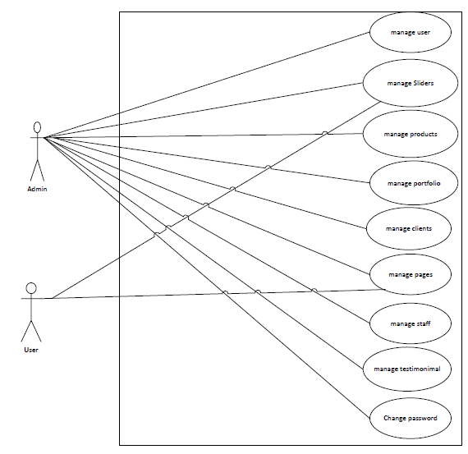Fig 3.1: Use case Diagram

Table 3.1 Manage Create User

|  |  |
| --- | --- |
| **Use case Identifier** | **UC1-manage Create User** |
| **Primary action** | Admin |
| **Secondary action** | None |
| **Description** | The admin should be able to create user. |
| **Pre-condition** | The user must be logged in as admin. |
| **Post-condition** | The create user list is updated in the database.An appropriate success message is shown on screen. |
| **Failure scenario** | The database is not update. Success or error message is not displayed on the screen. |

Table 3.2 Manage Product

|  |  |
| --- | --- |
| **Use case Identifier** | **UC2-manage product** |
| **Primary action** | Admin |
| **Secondary action** | None |
| **Description** | The admin should be able to add new products, modify the products, edit and delete any particular product. |
| **Pre-condition** | The user must be logged in as admin.The products should not be present if new products are being added. |
| **Post-condition** | The user must be logged in as admin.The products should not be present if new staffs are being added. |
| **Failure scenario** | The database is not updated. Success or error message is not displayed on the screen. |

Table 3.3 Manage staff

|  |  |
| --- | --- |
| **Use case Identifier** | **UC3-manage staff** |
| **Primary actor** | Admin |
| **Secondary actor** | None |
| **Description** | The admin should be able to add new staffs, modify the staffs, edit and delete any particular staffs. |
| **Pre-condition** | The user must be logged in as admin.The staffs should not be present if new staffs are being added. |
| **Post-condition** | The user must be logged in as admin.The staffs should not be present if new staffs are being added. |
| **Failure scenario** | The database is not updated. Success or error message is not displayed on the screen. |

Table 3.4 Manage Slider

|  |  |
| --- | --- |
| **Use case Identifier** | **UC4-manage slider** |
| **Primary actor** | Admin |
| **Secondary actor** | None |
| **Description** | The admin should be able to add new sliders, modify the slider, edit and delete any particular slider. |
| **Pre-condition** | The user must be logged in as admin.The slider should not be present if new slider is being added. |
| **Post-condition** | The slider list is updated in the database. An appropriate success message is shown on the screen. |
| **Failure scenario** | The database is not updated. Success or error message is not displayed on the screen. |

Table 3.5 Manage Portfolio

|  |  |
| --- | --- |
| **Use case Identifier** | **UC5-manage portfolio** |
| **Primary action** | Admin |
| **Secondary action** | None |
| **Description** | The admin should be able to add new portfolio, modify the portfolio, edit and delete any particular portfolio. |
| **Pre-condition** | The user must be logged in as admin.The portfolio should not be present if new portfolio is being added. |
| **Post-condition** | The portfolio list is updated in the database. An appropriate success message is shown on the screen. |
| **Failure scenario** | The database is not updated. Success or error message is not displayed on the screen. |

Table 3.6 manage Client

|  |  |
| --- | --- |
| **Use case Identifier** | **UC6-manage client** |
| **Primary action** | Admin |
| **Secondary action** | None |
| **Description** | The admin should be able to add new client, modify the client, edit and delete any particular client. |
| **Pre-condition** | The user must be logged in as admin.The client should not be present if new client is being added. |
| **Post-condition** | The client list is updated in the database. An appropriate success message is shown on the screen. |
| **Failure scenario** | The database is not updated. Success or error message is not displayed on the screen. |

### 

Table 3.7 Manage Testimonial

|  |  |
| --- | --- |
| **Use case Identifier** | **UC7-manage testimonial** |
| **Primary action** | Admin |
| **Secondary action** | None |
| **Description** | The admin should be able to add new testimonial, modify the testimonial, edit and delete any particular testimonial. |
| **Pre-condition** | The user must be logged in as admin.The client should not be present if new testimonial is being added. |
| **Post-condition** | The testimonial list is updated in the database. An appropriate success message is shown on the screen. |
| **Failure scenario** | The database is not updated. Success or error message is not displayed on the screen. |

Table 3.8 Manage Pages

|  |  |
| --- | --- |
| **Use case Identifier** | **UC8-manage pages** |
| **Primary action** | Admin |
| **Secondary action** | None |
| **Description** | The admin should be able to add new pages, modify the pages, edit and delete any particular pages. |
| **Pre-condition** | The user must be logged in as admin.The client should not be present if new pages is being added. |
| **Post-condition** | The pages list is updated in the database. An appropriate success message is shown on the screen. |
| **Failure scenario** | The database is not updated. Success or error message is not displayed on the screen. |

### 3.2.3 Non-functional Requirements

Non- functional requirements are those requirements other than the functional requirements. This requirement is the backbone of the any system. Non- functional requirement helps to boost the performance, characteristics and speed of the system.

### 3.2.3.1 Performance

It requires minimal hardware features. It stores the information of the portfolio, pages, testimonials, clients and detailed information of the Agrocorp Company. So, it requires more than 1 GB hard disk.

### 3.2.3.2 Hardware

It is a web based CMS and it requires internet and browser to run. Different browser that supports PHP, JavaScript can operate this website.

### 3.2.3.3 Software

It will be used on PCs and will function via internet or internet in any latest web browser. Admin can monitor the user easily through the system. Creating and managing the contents does not require more effort. Large numbers of data can be added in the system easily. The website will be developed by the use of HTML, CSS and JavaScript. Its database model will support MYSQL environment as DBMS.

## 3.3 Feasibility Study

The feasibility study is an analysis of how successfully a project can be completed accounting for factors that affect it such as economic, technological, operational and scheduling factors.

The different analysis of the system is carried out below:

### 3.3.1 Technical Feasibility

User’s requirements can be easily accumulated and is technically feasible to work upon. We used as server script and HTML, CSS and JavaScript to develop the frontend of

website. Apache is used a backend server and as a database server we used MYSQL Server.

### 3.3.2 Operational Feasibility

Operational Feasibility is a measure of how well a proposed system solves the problems. The requirements for the system are feasible to operate and translate them into the system. Use of different technology like PHP for backend to interact with database and HTML, CSS, JavaScript for the UI design made the system operationally feasible to build.

### 3.3.3 Economic Feasibility

User’s requirements can be accumulated and is economically feasible to work upon. We used PHP as server script and HTML, CSS and JavaScript to develop the frontend of the site. Apache is used as a backend server and as a database server we used MySQL Server.

### 3.3.4 Schedule Feasibility

The project fails if it takes too long to be completed before it is useful. Typically, this means estimating how long the system will take it to develop. Although this site can be enlarge as required but it was developed with functionalities that were enough for the institute. So, it reduces the time cost for its development and had enough time to complete it.

## 3.4 Data Model of System

### 3.4.1 EER Diagram

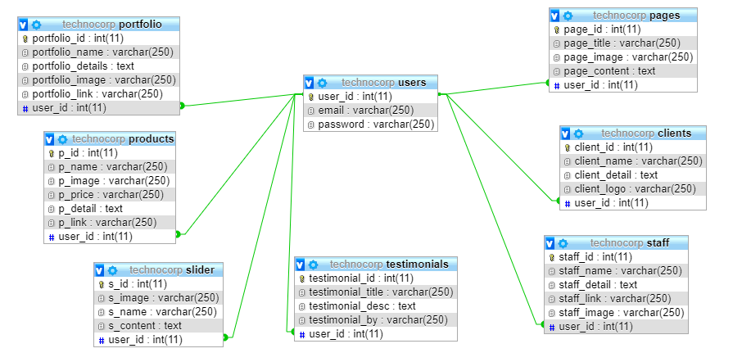

**CHAPTER 4****:SYSTEM DESIGN**

## 

## 4.1 Architectural Design

Browser Browser

1st tire

Request Response

Server

Middle tire

DB

Database tire

Figure 4.1: Architectural design diagram

It shows the operations (actions) involved in performing some use-cases. It shows the step-wise decomposition/transition and control flows while implementing a certain use-case. It also shows the alternative path, concurrent path to execute a particular use-case.

## 4.2. Activity Diagram

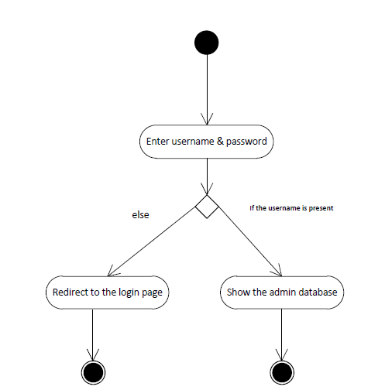

Figure 4.2: Activity Diagram of login

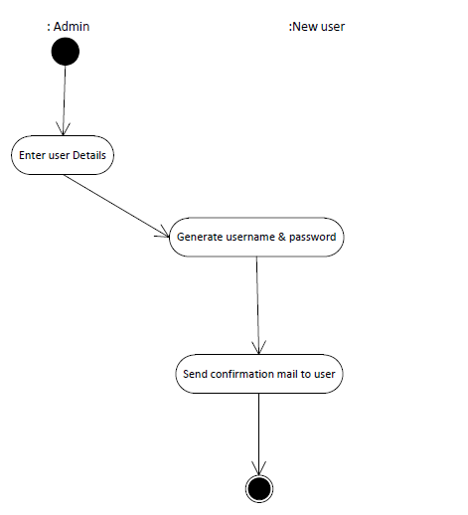

Figure 4.3: Activity Diagram of Create User

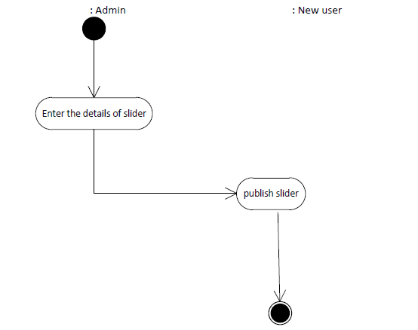

Figure 4.4: Activity Diagram of Slider

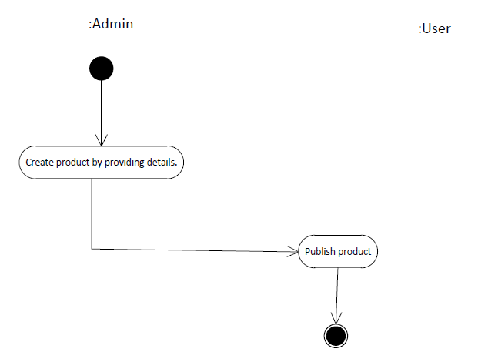

Figure 4.5: Activity Diagram of product

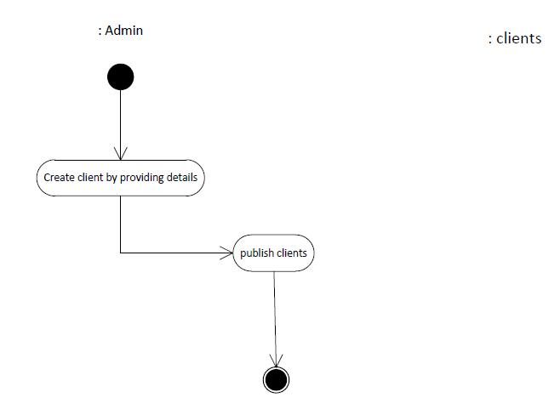

Figure 4.6: Activity Diagram of clients

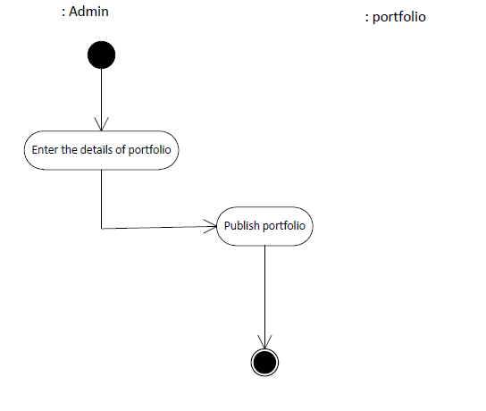

Figure 4.7: Activity Diagram of portfolio

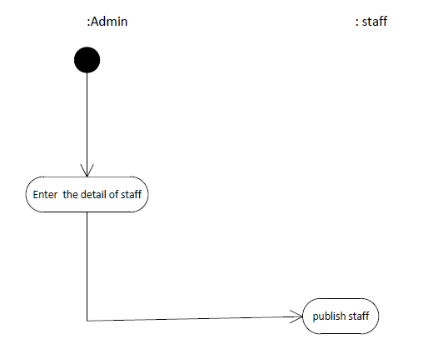

Figure 4.8: Activity Diagram of staff

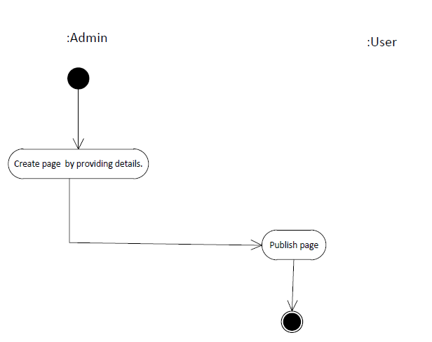

Figure 4.9: Activity Diagram of page

## C:\Users\Kajal shah\Pictures\109.PNG

Figure 4.10: Activity Diagram of change password

## 

## 

## 4.3 Sequence Diagram

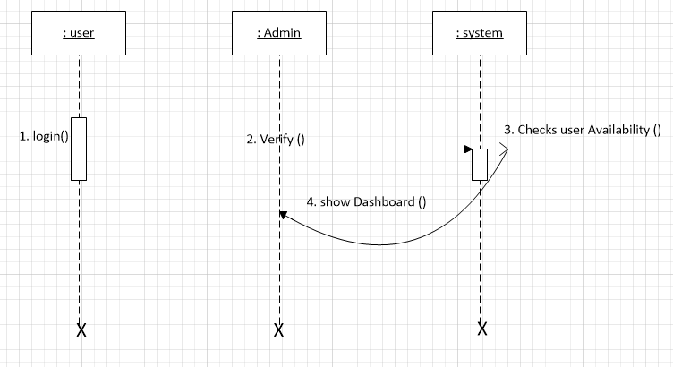

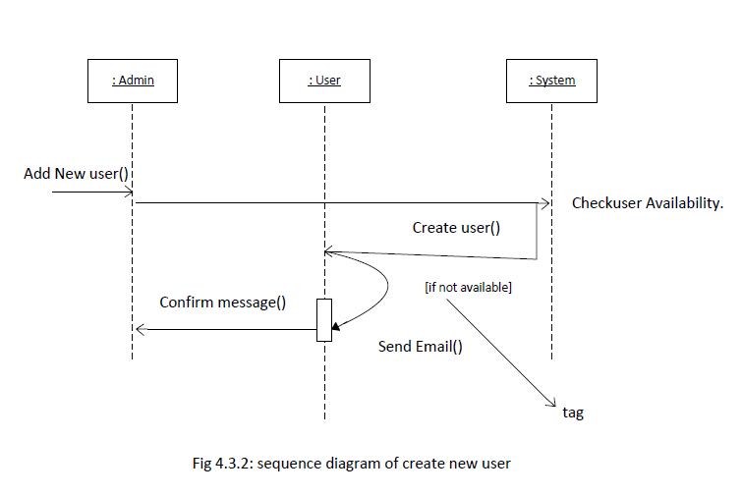

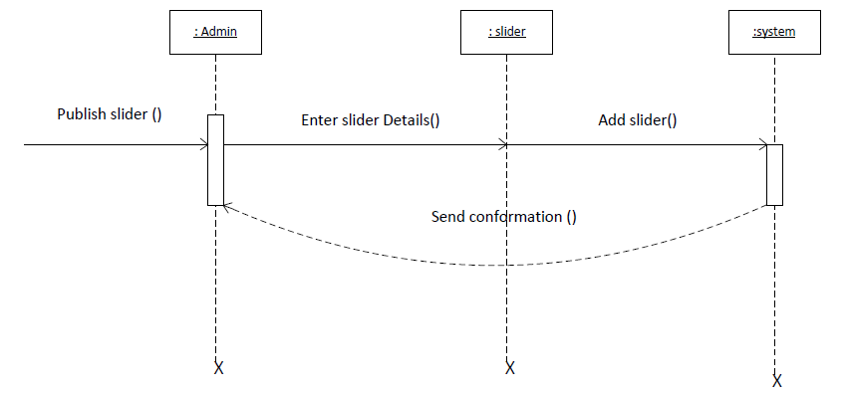

Figure 4.13: Sequence Diagram of Slider

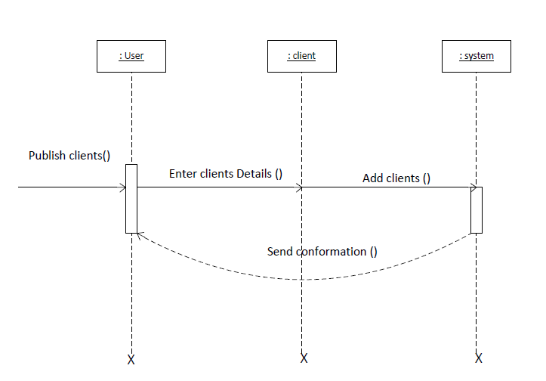

Figure 4.14: Sequence Diagram of Clients

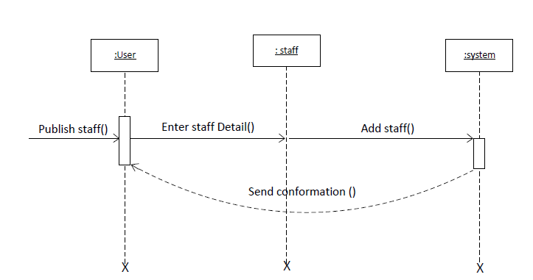

Figure 4.15: Sequence Diagram of Staff

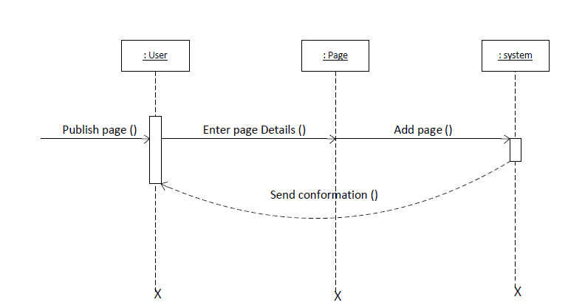

Figure 4.17: Sequence Diagram of pages

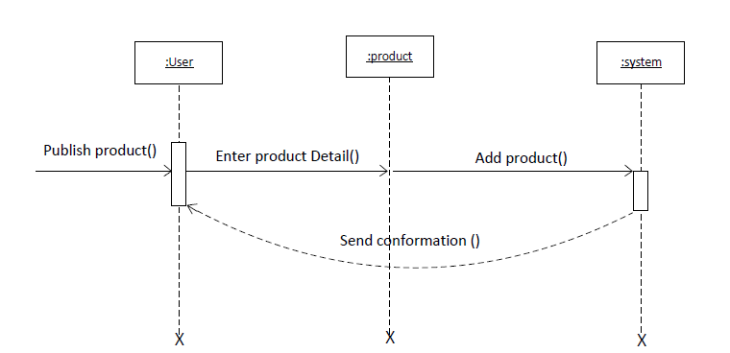

Figure 4.18: Sequence Diagram of products

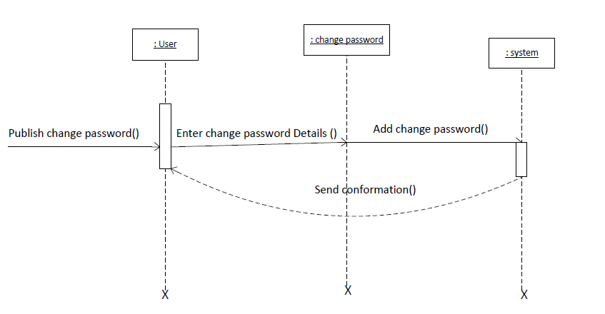

Figure 4.19: Sequence Diagram of Change Password

# 

## 

## 

# CHAPTER 5:IMPLEMENTATION AND TESTING

## 5.1. Implementation Methodology

The earlier a defect is found in the system implementation. System Implementation specifies how the system is installed operated and maintained. System implementation is also known as the testprogram that performs the complete system in its actual environment to determine its capabilities and limitations. Testing early in the system life cycle will reduce risks such as schedule delays or cost overruns due to incomplete or unacceptable.

Following a proper implementation method and testing of the system will prove that the system meets all its requirements, including those for performance and security.

## 5.2. Implementation Tools

### 5.2.1. Sublime Text:

Sublime Text is a proprietary cross-platform source code editor. Sublime Text has been used as a Text editor.

### 5.2.2. Microsoft Visio

Microsoft Vision along with Lucid Chart was used as design tool for creating use-case, activity diagram, and sequence diagram and other required diagram.

### 5.2.3. Frontend and Backend Tools

### 5.2.3.1 Front End Tools

**1) HTML:** HTML stands for Hyper Text Markup Language.It describes the structure of Web pages using markup html elements are the building blocks of HTML pages. HTML elements are represented by tags label pieces of content such as “heading”,”paragraph”,”table”, and so on.

**2) CSS:** CSS is easy to learn and understand but it provides powerful control over the presentation of an HTML document. Most commonly, CSS is combined with the markup languages HTML or XHTML.

**3) jQuery:**jQuery is a fast and concise JavaScript Library created by John Resig in 2006 with a nice motto: Write less, do more. jQuery simplifies HTML document traversing, event handling, animating, and Ajax interactions for rapid web development. jQuery is a JavaScript toolkit designed to simplify various tasks by writing less code.

### 5.2.3.2 Back End Tools

**1) Apache:**Apache is a freely available Web server that is distributed under an "open source" license. Version 2.0 runs on most UNIX-based operating systems (such as LINUX, Digital UNIX, and AIX), on other UNIX/POSIX-derived systems (such as Rhapsody, and BS2000/OSD), on AmigaOS, and on Windows.

**2) PHP:** PHP is a recursive acronym for "PHP: Hypertext Preprocessor".PHP is a server side scripting language that is embedded in HTML. It is used to manage dynamic content, databases, session tracking, even build entire e-commerce sites.It is integrated with a number of popular databases, including MySQL, PostgreSQL, Oracle, Sybase, Informix, and Microsoft SQL Server.

### 5.2.3.3 Database

**1) MySQL:**MySQL operates along with several utility programs which support the administration of MySQL databases. Commands are sent to MySQLServer via the MySQL client, which is installed on a computer.

### 5.3. Testing

Testing is used at key checkpoints in overall process to determine whether objectives are being met. Upon accomplishment of each use case, the system is fully tested using the following strategies (unit testing, integration testing).

### 5.3.1. Testing Objective

a) To discover the cause of these errors.

b) To force a program to run efficiently.

c) To revise the program code to eliminate errors.

d) To identify unhandled exceptions such as input of invalid/unexpected types.

### 5.3.2. Test Cases

|  |  |  |  |  |  |
| --- | --- | --- | --- | --- | --- |
| Test  cases-Id | Module name | Test data | Expected result | Actual result | Remarks |
| 1. | Admin login | Enter username and password | Enters to the admin page | Invalid Username/password | Fail |

|  |  |  |  |  |  |
| --- | --- | --- | --- | --- | --- |
| 2. | Add new user | Admin add new user as site moderator | New user is created | New user is created | Pass |
| 3. | Delete user | Admin delete the users account | User should be deleted | Users account has been deleted | Pass |
| 4. | Manage slider | Admin/user adds images for the slider | New slider must be added | New slider has been added | Pass |
| 5. | Manage clients | Admin/user adds name, detail, logo for the clients | New client must be added | New client has been added | Pass |
| 6. | Manage portfolio | Admin/user adds name, detail,image, link for the portfolio | New portfolio must be added | New portfolio has been added | Pass |
| 7. | Manage testimonial | Admin/user addstitle,description for the testimonial | New testimonial must be added | New testimonial has been added | Pass |
| 8. | Manage staff | Admin/user adds name,details,link and images for the staff | New staff must be added | New staff has been added | Pass |
| 9. | Manage pages | Admin/user adds images,title,content for the pages | New pages must be added | New pages has not been added | Fail |
| 10. | Manage products | Admin/user adds name,details,price,link,images for the products | New products must be added | New products has been added | Pass |

# CHAPTER 6:CONCLUSION

## 6.1. Summary

This project was done as a part of internship project for Bachelors of Science Computer Science and Information Technology (Bsc.csit) program offered by Tribhuvan University, Nepal. It was undertaken to plan, design and develop aCMS for Agriculture Company.

By the development of the project, the project was a complete dynamic website for Agriculture company which allows to manage the day to day operations of the Agriculture company and main it aims to have a good interaction with the clients and guests who visits the websites. The system has been developed with much care that it is free of errors and less time consuming.

The advantage is that this can be enhanced, modified or changed to the growing requirements of the client, and it is developed using open source software.

## 6.2. Lesson Learnt

Being in the internship program and handling the designation of PHP developer, I learned a lot of employee valued skills. I learned about the good personal presentation. I learned developer’ skills and also learned how to use the developer’s tools. The internship has taught me time management, as working in a company means you have to take care of the deadlines and milestones. This internship has been an excellent and rewarding experience. It has been a great opportunity to improve personal and professional skills. This valueable skill has boosted my professional skills to higher level and prepares me for better future in this career

# REFRENCES

# 

# 

## 

# 

## 

# Appendix

## Screenshots

